
a
Company
Logotype

Cone Beam Computed Tomography- Report



Porur Dental X-rays & CBCT

Patient Name : Mrs. Shanthi | Date of Report : 22.05.2024
Age/ Gender : 59 years/ Female | Region of Interest : CBCT Full Skull
Referring doctor: Dr. I. Porkodi | Indication : Implant assessment
Clinical Notes: Nil
PATIENT INFORMATION

CBCT- Full Skull provided
CBCT – IMAGE DETAILS

RADIOGRAPHIC INTERPRETATION

- No of teeth present in the maxillary and mandibular arch: 24; Missing tooth: 17, 18, 24, 26, 28, 38, 47, 48.
- Root stumps: 13, 14, 15, 22, 23, 31, 46.
- The maxillary and mandibular alveolar ridges are present with normal trabecular pattern.
- Hyperdense crown structure in relation to 32, 33, 34, 35, 36, 37, 42, 43, 44, 45.

IMPLANT ASSESSMENT

 | 11 region | 12 region | 13 region | 14 region | 21 region | 22 region | 23 region | 24 region
Sub-Crestal | 5.1 | 6 | 6.1 | 4.7 | 5.3 | 4.6 | 5.5 | 5.8
Mid- Crestal | 5.3 | 4.5 | 5.8 | 5.2 | 4.8 | 4.3 | 5 | 5.9
Distance between the alveolar ridge and Floor of the Nasal cavity (in mm) | 15.8 | 17.3 | 20.6 | 10.6 | 18.6 | 18 | 13 | 13.6

 | 15 region | 16 region | 17 region | 25 region | 26 region | 27 region
Sub-Crestal (in mm) | 8.6 | 12.8 | 10.4 | 4.8 | 6.9 | -
Mid- Crestal (in mm) | 9.1 | - | - | 5.2 | - | -
Distance between the alveolar ridge and floor of the maxillary sinus (in mm) | 4.7 | 2.8 | 5 | 11 | 3.8 | 1.1

 | 46 region | 47 region
Sub-Crestal (in mm) | 5.5 | 5.3
Mid- Crestal (in mm) | 7.7 | 6.7
Distance between alveolar ridge and the inferior alveolar nerve canal (in mm) | 10.6 | 11.8
Distance between alveolar ridge and the inferior border of mandible (in mm) | 22.9 | 22.2

RADIOGRAPHIC IMPRESSION

- Partially edentulous maxillary and mandibular arch.
- Root stumps: 13, 14, 15, 22, 23, 31, 46.
- Crown in relation to 32, 33, 34, 35, 36, 37, 42, 43, 44, 45

Kindly correlate with clinical findings


IMAGES FOR REFERENCE

RECONSTRUCTED PANORAMIC VIEW

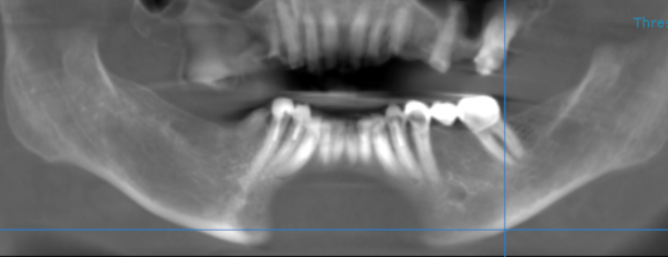
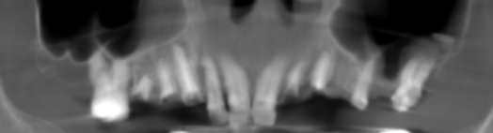

3-DIMENSIONAL VIEW

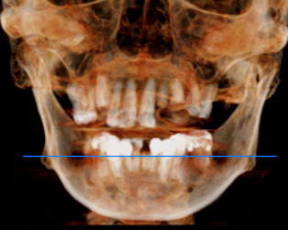

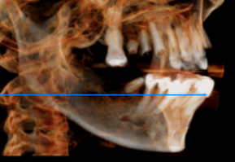
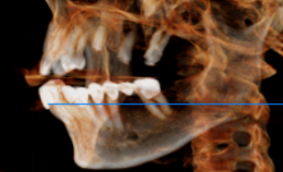

CROSS SECTIONAL VIEW

11 region | 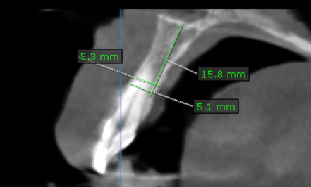
12 region | 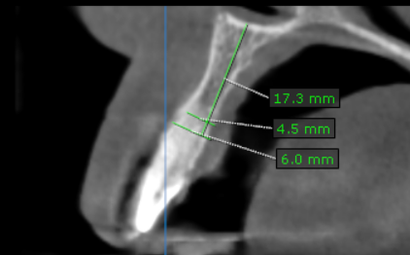
13 region | 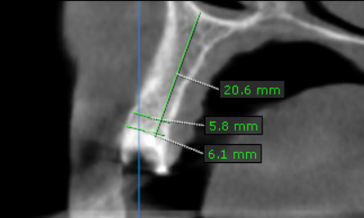
14 region | 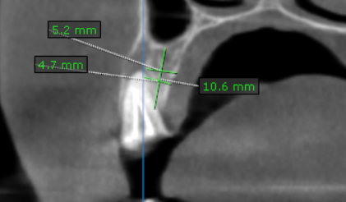
15 region | 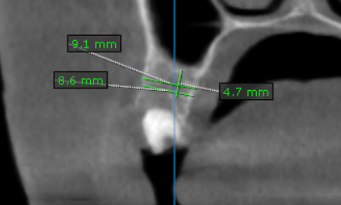
16 region | 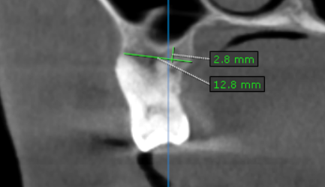
17 region | 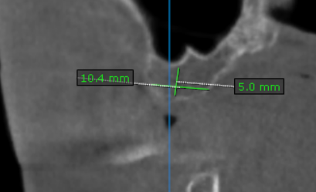
21 region | 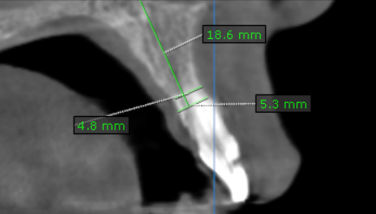
22 region | 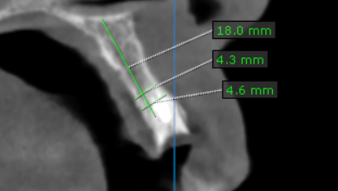
23 region | 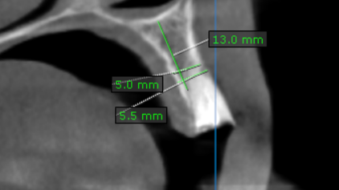
24 region | 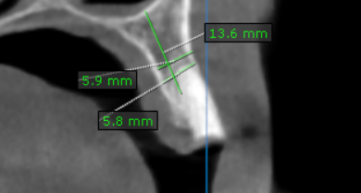
25 region | 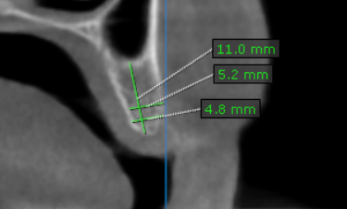
26 region | 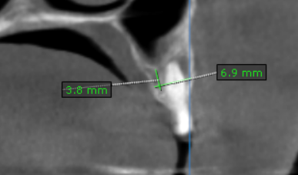
27 region | 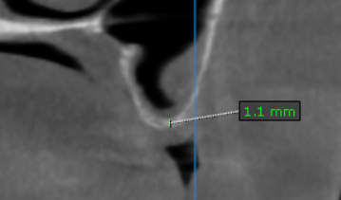
46 region | 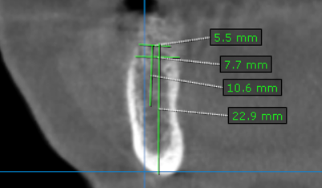
47 region | 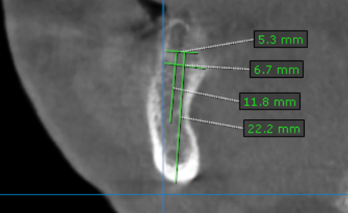

**** End of report ****

